**Ormskirk & District Family History Society - APPLICATION FOR MEMBERSHIP**

***For online membership applications, go to the Membership page of the website*** [***www.odfhs.website/index.php/membership***](http://www.odfhs.website/index.php/membership)

Membership runs from 1 April in the current year to 31 March in the following year. (Applications between 1 January and 31 March run to 31 March in the following year)

NB The Society handles your personal information in a way that complies with the current GDPR

**Title………..First Name(s)………..……………………… Surname………………………………………. Date………….**

**Address..........................................................................................................................................................................................**

**..............................................................................................................................................Post Code…………………………**

**Telephone…………....................................... e-mail address………………………..………………………………………..**

**I (we) wish to apply for membership for 202…./2….. (Tick type below)**

**[ ] UK Membership with Postal Mag. £15.00 (from 1 January 2024)**

**[ ] Overseas Membership with Postal Mag. £20.00 “ “**

**[ ] UK or Overseas Membership with E-Mag. £11.00 “ “**

**Method of Payment: Please tick the appropriate box to indicate method of payment and return the completed form to: The Treasurer, ODFHS, 15 Greetby Hill, Ormskirk, Lancashire, L39 2DP (or by email to** [**treasurerodfhs@gmail.com**](mailto:treasurerodfhs@gmail.com)**) unless you have applied online.**

**[ ] CHEQUE -** Payable to ‘Ormskirk & District Family History Society’ and enclosed with this form

**[ ] BANK TRANSFER Sort Code** 77 57 01  **Account Number** 00007974

Please quote your surname and the word “New”.

**[ ] INTERNATIONAL IBAN** GB16TSBS77570100007974  **BIC** TSBSGB2AXXX

**BANK TRANSFER** Please quote your surname and the word “New”.

**[ ] DEBIT/CREDIT CARD –** Please go to [www.parishchest.com/ormskirk-district-fhs-3508.php](http://www.parishchest.com/ormskirk-district-fhs-3508.php)

**[ ] PAYPAL –** Please go to[***www.odfhs.website/index.php/membership***](http://www.odfhs.website/index.php/membership)and apply online

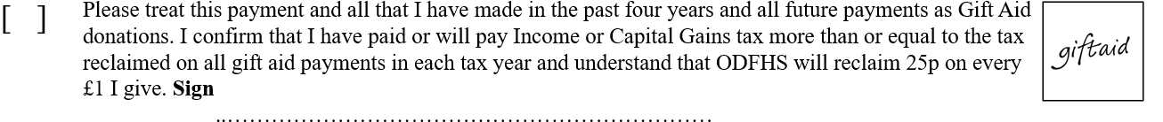

**MEMBERS' INTERESTS: PLEASE GIVE DETAILS OF NAMES THAT YOU ARE RESEARCHING**

(add years and locations if you wish and continue on reverse if necessary)

1. ……………………………………………… 2) …………………………………………………

3) ………………………………………………… 4) …………………………………………………

5) ………………………………………………… 6) …………………………………………………

Would you like these to be included in the next issue of our Newsletter / Society Magazine? Yes / No

Would you like these to be included in our Members’ Interests Directory? Yes / No

If other members share your interests may we pass on to them:

Your name? Yes / No Your e-mail address? Yes / No

Your postal address? Yes / No Your telephone number? Yes / No